TF-1. Intraday Trade Fails Workflow and Dashboard
Functional Specification

Document Version | 1.0 — Draft for Review
Date | March 9, 2026
Prepared By | Scott Cable
Client | Cantor Fitzgerald Securities
Project | TF-1. Intraday Trade Fails Workflow and Dashboard
Status | CLIENT INITIAL REVIEW

Document History
Version | Responsible | Date | Notes
1.0 | Scott Cable | March 9, 2026 | Initial version issued for client review and approval.

Document Approval
This document confirms the agreed functional behavior of the TF-1 Intraday Trade Fails Workflow and Dashboard as described in this Functional Specification.
Approval confirms that the functional behavior defined in this document represents the baseline for implementation and testing of the TF-1 solution in accordance with the Statement of Work.
This approval applies to the following document:
Functional Specification – TF-1. Intraday Trade Fails Workflow and Dashboard v1.0
Dated March 9, 2026
Organization | Name | Role | Signature | Date
Cantor Fitzgerald | Tom Anzalone | Executive Sponsor / Settlements Lead

Table of Contents
1. Introduction 7
1.1 Purpose 7
1.2 Role of This Functional Specification 7
1.3 Scope 8
1.4 Out of Scope 8
2. Solution Overview and System Boundary 9
2.1 Overview of the TF-1 Solution 9
2.2 Human Actors and User Roles 9
2.3 Upstream Data Sources 10
2.4 System Boundary and Responsibilities 10
3. Intraday Monitoring and Fail Record Identification 11
3.1 Monitoring Population 11
3.2 Fail Record State (Workflow) 12
3.3 Settlement Condition (Derived) 12
3.4 Separation of Monitoring and Resolution 13
4. Upstream Data Availability Handling 14
4.1 Settlement Status Availability 14
4.2 RAD Approval Status Availability 15
4.3 Position Data Availability 15
4.4 Pricing Data Availability 15
5. Exposure and Prioritization Behavior 16
5.1 Purpose 16
5.2 DTC Box Position Source 16
5.3 DTC Box Market Value Calculation 16
5.4 View 1 Ordering Logic 17
5.5 Advisory Nature of Prioritization 17
6. User Interaction and Status Behavior 17
6.1 Purpose 17
6.2 Handling Status (Obligation-Level Coordination Flag) 17
6.3 Operational Notes 19
6.4 Record Closure (System-Driven) 19
6.5 Interaction Boundaries 20
7. Data Sources, Context, and Derived Values 20
7.1 Overview 20
7.2 Settlement Obligation Data 20
7.3 Approval Status Data 21
7.4 Position Data (DTC Box) 22
7.5 Pricing Data 22
7.6 Derived Values 23
7.7 Data Authority and Precedence 24
8. Dashboard View Structure and Interaction Behavior 24
8.1 Overview 24
8.1.1 Date and Time Display Convention 25
8.2 View 1 – Box Exposure View 25
8.3 View 2 – RAD Exceptions View 30
8.4 Cross-View Behavioral Constraints 33
9. Exception Handling and Edge Cases 33
9.1 Data Availability and Quality Exceptions 34
9.2 Timing and Sequencing Edge Cases 34
9.3 User Interaction Edge Cases 35
9.4 Unsupported or Out-of-Scope Scenarios 35
9.5 System and Platform Constraints 36
10. Auditability and Traceability 36
10.1 Event History and Change Tracking 36
10.2 User-Entered Notes and Commentary 37
10.3 Constraints and Notes 37
11 Assumptions, Dependencies, and Open Items 38
11.1 Assumptions 38
11.2 Dependencies 38
11.3 Known Open Items 39
11.4 Change Control 39
Appendix A – Prototype Dashboard Screens (Illustrative) 41
A.1 View 1 – Box Exposure View 41
A.2 View 2 – RAD Exceptions View 42
A.2 Notes 42

1. Introduction

1.1 Purpose
This Functional Specification defines the agreed functional behavior of the TF-1 Intraday Trade Fails Workflow and Dashboard.
The Workflow performs deterministic intraday evaluation of settlement obligations based on settlement status, approval status, position, and exposure context.
The Dashboard surfaces Workflow outputs and associated operational context to authorized Cantor users to support informed manual intervention during the settlement day.
TF-1 is advisory and visibility-focused. It does not:
- Automatically initiate settlement actions.
- Execute or optimize stock borrowing.
- Send automated external communications.
- Modify upstream systems of record.
All operational decisions and resolution actions remain outside the TF-1 solution.

1.2 Role of This Functional Specification
This Functional Specification serves as the reference artifact for:
- Workflow and Dashboard configuration
- Functional and User Acceptance Testing
- Demonstrations and acceptance activities
The behavior described in this document is strictly bounded by the scope, assumptions, and exclusions set out in the signed Statement of Work.

1.3 Scope
This Functional Specification describes:
- Intraday monitoring of settlement obligations.
- Identification and activation of fail records.
- Deterministic evaluation of settlement obligation state based on settlement status, approval status, position, and exposure context.
- Exposure calculation and prioritization behavior.
- User interaction, handling status, and lifecycle behavior.
- Dashboard view structure and interaction behavior.
- Data dependencies and system constraints.
The scope of this document is limited to the behavior required to implement and demonstrate the Workflow and Dashboard in accordance with the Statement of Work.

1.4 Out of Scope
This Functional Specification explicitly excludes:
- Commercial terms, fees, and payment milestones.
- Detailed project planning, delivery sequencing, or sprint breakdowns.
- Technical implementation design (HLSD / LLD), infrastructure configuration, or deployment scripts.
- Detailed data mapping specifications beyond functional field behavior.
- Environment provisioning, access configuration, or operational runbooks.
Such items are governed by the Statement of Work, project plans, technical design artifacts, or internal delivery documentation as applicable.

2. Solution Overview and System Boundary

2.1 Overview of the TF-1 Solution
The TF-1 Intraday Trade Fails Workflow and Dashboard comprises two integrated components:
- The Workflow, which performs deterministic intraday monitoring and evaluation of settlement obligations.
- The Dashboard, which presents Workflow outputs and associated operational context to authorized users.
The Workflow and Dashboard operate together to provide intraday visibility and prioritization of settlement obligation delivery fails.
The Workflow evaluates settlement, approval, position, and pricing data to determine:
- Whether a settlement obligation has failed based on DTC settlement status events or settlement date evaluation.
- Relevant contextual data required for operational review.
The Dashboard surfaces this information in structured operational views to support informed manual intervention.
TF-1 does not execute settlement activity, borrowing, or counterparty communication. It provides advisory visibility only.

2.2 Human Actors and User Roles
TF-1 supports the following user roles.
Settlements Operations Users
- Primary operational users of the Dashboard.
- Responsible for:
  - Reviewing settlement obligation fails.
  - Prioritizing operational action.
  - Recording handling status and operational notes.
  - Coordinating resolution outside the system.
Stock Loan Desk Users
- May access the Dashboard and have the same interaction permissions as Settlements Operations Users in Version 1 (notes and handling status).
- Stock borrowing and loan activity remain outside TF-1.
Read-Only / Supervisory Users
- Have visibility for oversight and handover purposes.
- May not alter workflow-managed state unless explicitly granted permissions.

2.3 Upstream Data Sources
TF-1 consumes settlement, position, approval, and pricing data provided through Cantor-controlled integration mechanisms.
The solution relies on the following data domains:
- Settlement Obligation and Position Data
Including obligations scheduled to settle during the current settlement day and any prior-day obligations that remain open and associated position information.
- Settlement Status and Approval Data
Including DTC-derived settlement state and RAD approval status.
- Market Pricing Data
Used for exposure calculation and prioritization ordering.
TF-1 does not define or control the upstream integration topology. Data is consumed as provided via Cantor-managed systems and environments in accordance with the Statement of Work.

2.4 System Boundary and Responsibilities
TF-1 operates within Cantor-controlled environments.
The solution:
- Consumes upstream data provided by Cantor.
- Evaluates settlement obligation fails.
- Surfaces results via the Dashboard.
- Persists user-recorded handling status and notes.
The solution does not:
- Modify upstream systems of record.
- Initiate settlement transactions.
- Execute stock borrowing.
- Send automated counterparty communications.
- Override DTC or external system state.
Responsibility for data provision, environment readiness, and infrastructure remains with Cantor, as defined in the Statement of Work.

3. Intraday Monitoring and Fail Record Identification

3.1 Monitoring Population
TF-1 monitors settlement obligations provided via Cantor-controlled settlement and position data feeds.
The monitoring population includes:
- Settlement obligations scheduled to settle on the current business day.
- Settlement obligations with settlement dates prior to the current business day that remain open and unsettled (carry obligations), where such records are provided in the upstream data feed.
Carry obligations remain within the monitoring population until a settlement completion event is received indicating that the obligation has settled or otherwise closed.
TF-1 does not independently generate settlement obligations. It evaluates obligations as provided via Cantor-controlled integration mechanisms.

3.2 Fail Record State (Workflow)
For settlement obligations within the monitoring population, TF-1 maintains a corresponding fail record.
A fail record is in one of two workflow states:
- Active: The obligation remains open and has not received a settlement completion event.
- Closed: The obligation is confirmed as settled or otherwise closed through an upstream settlement completion event.
Fail record state is system-driven and based solely on upstream data signals.
Users cannot manually activate or close fail records.

3.3 Settlement Condition (Derived)
For Active settlement obligations within the monitoring population, TF-1 derives a Settlement Condition based on upstream settlement status events and settlement date evaluation.
Settlement Condition reflects the current settlement state of the obligation based on the most recent upstream signals available to TF-1.
Where settlement status is determinable, Settlement Condition may take the following values:

Failed
An obligation is treated as Failed where either of the following conditions applies:
- DTC Failure Signal
The obligation is indicated by upstream DTC settlement status messages as failed to settle on the applicable settlement date. Delivery-side failed settlements constitute Fail-to-Deliver (FTD).
- Carry Fail Determination
The settlement date of the obligation is prior to the current business date used for TF-1 settlement monitoring and no upstream settlement completion event has been received for the obligation.

Settled
An obligation is treated as Settled where upstream settlement status events indicate that the obligation has successfully settled or the fail has otherwise been cleared.
Upon confirmation of settlement, the corresponding fail record transitions to Closed state as defined in Section 3.2.

Unassigned (No Settlement Status Yet)
Where no settlement status event has yet been received from upstream systems, the Settlement Condition remains unassigned.
In this state:
- the obligation remains part of the monitoring population
- the obligation may later transition to Failed or Settled once additional upstream events are received

Notes
- Settlement Completion Event: An upstream event indicating that the settlement obligation has settled or otherwise closed.
- RAD approval status alone does not constitute failure.
- Settlement condition is not user-editable.
- Settlement condition does not by itself determine Dashboard inclusion; inclusion logic is defined separately in Section 8.

3.4 Separation of Monitoring and Resolution
TF-1:
- Identifies and tracks settlement obligation fails.
- Does not execute or automate settlement resolution.
- Does not modify upstream settlement records.
Operational resolution actions occur outside TF-1.

4. Upstream Data Availability Handling
TF-1 relies on multiple upstream data sources to evaluate settlement obligations and construct dashboard views.
Where upstream data is missing, delayed, or inconsistent, TF-1 applies deterministic handling rules to ensure predictable system behavior.
TF-1 does not infer operational states from missing data. Records are evaluated only using explicitly provided upstream signals.
Where required upstream data is unavailable, records remain subject to automatic re-evaluation as updated data is received through the normal TF-1 processing cycle.

4.1 Settlement Status Availability
Settlement status sourced from DTC is authoritative for determining settlement outcome where such status is available.
Where settlement status is unavailable, TF-1 evaluates obligations as follows:
- For obligations with settlement date equal to the current business date, Settlement Condition remains unassigned until a valid settlement status event is received. The obligation is not treated as Failed or Settled during this period.
- For obligations with settlement dates prior to the current business date, TF-1 determines Settlement Condition using the carry-fail rule defined in Section 3.3. In such cases, the obligation is treated as Failed unless a settlement completion event has been received.
- The corresponding fail record remains in the Active state, consistent with the workflow definition in Section 3.2.
- Dashboard inclusion rules dependent on settlement outcome are evaluated based on the derived Settlement Condition defined in Section 3.3.

4.2 RAD Approval Status Availability
RAD approval status determines whether an obligation qualifies for the Unapproved RAD view (View 2).
Where RAD approval status is unavailable:
- The approval state is treated as Unknown.
- The obligation is not included in the Unapproved RAD view unless explicitly marked Unapproved.

4.3 Position Data Availability
Position data determines the DTC Box Position used for exposure evaluation and Box-driven inclusion logic.
Where position data is unavailable:
- The DTC Box Position is treated as unknown.
- Inclusion rules dependent on Box Position cannot be evaluated until valid position data is received.

4.4 Pricing Data Availability
Market pricing is used for exposure valuation and exposure-based prioritization.
Where pricing data is unavailable:
- Exposure calculations dependent on pricing data cannot be computed.
- Exposure-based prioritization cannot be applied.
Pricing refresh behavior and retrieval logic are defined in Section 7.5.

5. Exposure and Prioritization Behavior

5.1 Purpose
TF-1 provides exposure-based visibility to support prioritization of securities with settlement obligation fails.
Prioritization in the Box Exposure View is driven by DTC Box Market Value at CUSIP level.
TF-1 does not execute or automate operational decisions.

5.2 DTC Box Position Source
DTC Box Position is sourced from Cantor-provided position data via upstream integration mechanisms.
TF-1:
- Retrieves DTC Box Position per CUSIP for the applicable firm/entity context.
- Treats the provided Box Position as authoritative.
- Does not independently calculate, derive, or reconcile box balances from trade activity.

5.3 DTC Box Market Value Calculation
DTC Box Market Value is calculated as:
DTC Box Position × Market Price
Where:
- DTC Box Position is sourced as described in Section 5.2.
- Market Price is sourced from the Market Price API.
Exposure values are recalculated when updated position or pricing data is received.
TF-1 does not simulate financing cost or optimization impact.

5.4 View 1 Ordering Logic
In the Box Exposure View:
- CUSIPs meeting the inclusion criteria defined in Section 8 are displayed.
- CUSIPs are ordered by DTC Box Market Value in descending order.
- Associated Fail-to-Deliver records are presented within the CUSIP grouping.
Ordering is applied at CUSIP level.
Individual fail records are not independently ranked in this view.

5.5 Advisory Nature of Prioritization
Exposure-based ordering supports visibility of higher financial impact securities first.
TF-1 does not:
- Enforce operational sequencing.
- Override business judgement.
- Initiate settlement action.

6. User Interaction and Status Behavior

6.1 Purpose
TF-1 enables authorized users to record operational handling context against Active settlement obligations.
User interaction does not modify upstream settlement, approval, or position data and does not alter workflow activation logic.

6.2 Handling Status (Obligation-Level Coordination Flag)
Handling Status is a manual, user-set coordination flag applied at the individual settlement obligation (trade) level.
Handling Status exists to support operational coordination between Settlements and Stock Loan users. It does not represent DTC settlement state, RAD approval state, or any automated workflow status.
Handling Status:
- Is persisted at obligation (trade) level.
- Is editable by authorized users (Settlements and Stock Loan).
- Does not alter inclusion criteria in any dashboard view.
- Does not alter ordering or prioritization logic.
- Does not trigger automated actions.
- Does not override DTC settlement condition or RAD status.
- Does not represent obligation completion. Obligation lifecycle remains governed by DTC settlement status.

6.2.1 Handling Status Values
The following Handling Status values are defined:
Status | Intended Meaning
New | Newly surfaced obligation; not yet reviewed.
Under Review | Being actively analyzed by Operations.
SL Assist | A request has been made to the Stock Loan desk for input or borrow support.
SL Actioned | The Stock Loan desk has taken action in response to a request (e.g. borrow attempted or executed).
Outreach Made | External contact (e.g. counterparty or client) has been initiated.
Awaiting | Waiting on response or follow-up action from an internal or external party.
Monitoring | Decision taken to observe rather than intervene immediately.
Actioned | A non-stock-loan operational step has been completed (e.g. escalation, allocation adjustment, internal resolution step).

Handling Status reflects operational coordination only.
Handling Status does not determine settlement state and does not automatically transition a fail record to Closed.
DTC settlement updates and RAD approval changes continue to govern obligation lifecycle and dashboard visibility.

6.3 Operational Notes
Users may record free-text operational notes against a trade/obligation record.
Operational notes:
- Are stored within TF-1.
- Do not alter settlement outcome.
- Do not influence inclusion or prioritization.
- Remain associated with the relevant trade/obligation record and are preserved in accordance with applicable data retention policies.

6.4 Record Closure (System-Driven)
Closure of a fail record is system-driven and based on upstream data.
A fail record transitions from Active to Closed when the underlying settlement obligation is confirmed as settled or otherwise closed through an upstream settlement completion event.
Users cannot manually close fail records within TF-1.

6.5 Interaction Boundaries
TF-1 does not:
- Submit or modify RAD approvals.
- Execute stock borrowing or trading activity.
- Modify DTC or Phase3 records.
- Send automated counterparty communications.
- Override settlement state.
- Modify the underlying exposure calculation or system-defined inclusion rules.
User interaction is limited to visibility, status tracking, and note capture.

7. Data Sources, Context, and Derived Values

7.1 Overview
TF-1 consumes settlement, approval, position, and pricing data provided through Cantor-controlled integration mechanisms.
TF-1 evaluates and associates upstream data elements as necessary to maintain an obligation-level intraday view consistent with the behaviors defined in this specification.
TF-1 does not override or replace upstream systems of record and does not perform financial ledger or position reconciliation.
Data is grouped into the following functional domains.

7.2 Settlement Obligation Data
Settlement obligation data defines the population monitored by TF-1.
For each settlement obligation within scope, the following data elements must be available to TF-1:
- Security identifiers (e.g. CUSIP; additional identifiers such as ISIN or SEDOL where provided).
- Delivery or receive indicator.
- Settlement date.
- Quantity.
- Net monetary trade amount (net_amount).
- Settlement status events (including failure and settlement completion indications).
Settlement status events are authoritative for determining whether an obligation has settled and, where provided, whether an obligation has failed to settle on the applicable settlement date.
TF-1 also derives failure for obligations with settlement dates prior to the current business date where no settlement completion event has been received, as defined in Section 3.
TF-1 evaluates obligations at the individual obligation level based on the data provided through Cantor-controlled integration mechanisms.

7.3 Approval Status Data
Approval status data provides the current RAD approval state for applicable settlement obligations.
This domain includes:
- Approval indicator (e.g. Approved, Unapproved).
- Associated identifiers linking approval state to the relevant settlement obligation.
Approval status:
- Is used to determine inclusion in the Unapproved RAD view (View 2).
- Provides operational context for settlement obligations.
- Does not independently determine failure.
- Does not override settlement status.
TF-1 associates approval data to settlement obligations using upstream-provided identifiers.

7.4 Position Data (DTC Box)
Position data provides DTC Box Position at CUSIP level for the relevant firm/entity scope.
This domain includes:
- DTC Box Position (shares).
- Associated security identifiers.
TF-1:
- Treats DTC Box Position as authoritative.
- Does not calculate or derive box balances from trade activity.
- Uses Box Position in exposure and ordering logic as defined in Section 5.

7.5 Pricing Data
Pricing data provides market price information used for exposure calculation.
This domain includes:
- Market price per security identifier.
Pricing data:
- Is used to calculate DTC Box Market Value.
- Does not affect settlement outcome.
- Is consumed as provided and is not independently validated by TF-1.

7.5.1 Pricing Refresh Behavior
Pricing data used for exposure calculation is refreshed on a scheduled basis.
In Version 1:
- Market pricing data is refreshed at a minimum frequency of once per hour.
- Exposure calculations (DTC Box Market Value and FTD / Box Ratio) reflect the most recently available pricing data at the time of the latest refresh cycle.
- Pricing updates do not require or trigger manual user action.
TF-1 does not perform tick-level or real-time market price streaming in Version 1.

7.5.2 Price Retrieval Trigger
Market price for a CUSIP is retrieved when the CUSIP first satisfies the inclusion criteria for display in a Dashboard view where DTC Box Market Value is required.
In Version 1 this may occur through either of the following:
View 1 – Box Exposure View
The CUSIP satisfies the View 1 inclusion criteria (DTC Box Position > 0 and at least one associated Active Fail-to-Deliver).
View 2 – RAD Exceptions View
An obligation for the CUSIP satisfies the View 2 inclusion criteria (RAD Status = Unapproved and the obligation remains Active as defined in Section 3.2).
Once retrieved, pricing data is refreshed in accordance with the refresh frequency defined in Section 7.5.1 for as long as the CUSIP continues to meet the applicable inclusion criteria for a view in which DTC Box Market Value is displayed.
TF-1 does not continuously retrieve pricing data for securities that do not meet inclusion criteria for any such view.

7.6 Derived Values
TF-1 derives certain values from sourced data, including:
- Settlement Condition, derived from upstream settlement status events and settlement date evaluation as defined in Section 3.
- DTC Box Market Value (DTC Box Position × Market Price), as defined in Section 5.
- Net Proceeds (Trade Value), sourced directly from the upstream settlement obligation field net_amount.
Derived values reflect the most recent upstream data available within TF-1 processing cycles.

7.7 Data Authority and Precedence
Where multiple upstream signals are received:
- DTC settlement status is authoritative for determining settlement outcomes and same-day failure signals.
- RAD approval status is authoritative for determining approval state.
- Position data is authoritative for DTC Box Position.
- Pricing data is authoritative for exposure valuation.
Handling of missing or inconsistent upstream data follows the rules defined in Section 4.

8. Dashboard View Structure and Interaction Behavior

8.1 Overview
The TF-1 Dashboard provides two operational views:
- View 1 – Box Exposure View
- View 2 – RAD Exceptions View
The Dashboard provides intraday visibility of settlement obligations and associated DTC positions, subject to upstream data availability, latency, and refresh cycles, to support prioritized operational intervention.
The Dashboard:
- Does not automatically initiate borrowing.
- Does not automatically initiate financing.
- Does not replace stock loan front-end systems.
- Does not perform automated workflow state transitions.
All actions remain user-driven in Version 1.

8.1.1 Date and Time Display Convention
Unless otherwise specified, all dates displayed within TF-1 follow the US date format: MM/DD/YYYY.
Where time is displayed, timestamps follow the format: MM/DD/YYYY HH:MM (24-hour clock).
This convention applies across all Dashboard views, drill-downs, tooltips, and exported outputs (e.g. EOD Snapshot).

8.2 View 1 – Box Exposure View

8.2.1 Inclusion Criteria
A CUSIP shall appear in View 1 only where:
- DTC Box Position (shares) > 0, and
- At least one Associated Active Fail-to-Deliver exists.
CUSIPs with only Fail-to-Receive obligations are excluded from this view.
CUSIPs with DTC Box Position ≤ 0 are excluded from this view.

8.2.2 Definition – Associated Active Fail-to-Deliver
A CUSIP is considered to have an Associated Active Fail-to-Deliver (FTD) where the underlying settlement dataset contains at least one delivery-side obligation record that:
- Matches the CUSIP, and
- Represents a delivery obligation of the firm, and
- Has Settlement Condition = Failed as defined in Section 3.3.
An obligation is considered Active as defined in Section 3.2.
RAD approval status does not determine whether a fail is active.

8.2.3 Top-Level Columns (Security Level)
Each row in View 1 represents a single CUSIP and displays the following fields:
Field Name | Display Label | Description | Level
CUSIP | CUSIP | Security identifier | Security
Symbol | Symbol | Security trading symbol | Security
DTC Box Position (Shares) | Box | Net DTC box position in shares | Security
DTC Box Market Value | MV | Market value of DTC box position | Security
Fail-to-Deliver Quantity | FTD | Aggregate quantity of active FTD obligations | Aggregated
Fail-to-Receive Quantity | FTR | Aggregate quantity of active FTR obligations (informational) | Aggregated
Fail-to-Deliver Net Trade Proceeds | FTD NP | Aggregate Net Trade Proceeds of all active Fail-to-Deliver obligations for the CUSIP. Calculated as the sum of the upstream net_amount field across those obligations. | Aggregated
FTD NP / Box Ratio (%) | Ratio | Proportional exposure metric calculated as Aggregate Fail-to-Deliver Net Trade Proceeds divided by DTC Box Market Value. Displayed as a percentage. | Derived
CNS Position | CNS | CNS position as provided by upstream feed | Security
Stock Loan Position | Loan | Stock loan position (start-of-day value in V1) | Security
Stock Borrow Position | Borrow | Stock borrow position (start-of-day value in V1) | Security
RAD Status Indicator | RAD | Boolean indicator: true if any associated obligation is RAD Unapproved | Derived

Where a Display Label is specified, it represents the column header shown in the Dashboard. Where no Display Label is specified, the Field Name is used as the column header.
Ratio is displayed as a percentage, rounded to one decimal place.
Ratio may exceed 100% where aggregate Fail-to-Deliver Net Trade Proceeds exceed DTC Box Market Value.
Valuation Basis
DTC Box Market Value is calculated as:
DTC Box Position × valuation price obtained from the Market Price API at the time of the most recent pricing refresh cycle.
Fail-to-Deliver Net Trade Proceeds are calculated as:
The sum of the upstream net_amount field across all active Fail-to-Deliver obligations associated with the CUSIP.
TF-1 does not recalculate, adjust, or revalue trade proceeds.
Market price is applied only to DTC Box Market Value and not to Fail-to-Deliver Net Trade Proceeds.

8.2.4 Aggregation Behavior
For each CUSIP:
- FTD and FTR quantities are aggregated from underlying obligation records.
- RAD indicator is derived as: TRUE where at least one associated obligation has RAD Status = Unapproved.
Stock Loan and Stock Borrow positions reflect start-of-day values in Version 1. Intraday updates to these values are out of scope for Version 1.
Field values are derived directly from upstream DTC and Phase 3 data feeds and do not alter source system calculations.

8.2.5 Default Ordering and Sorting
By default, rows are ordered by:
- DTC Box Market Value (MV) – descending
All displayed columns are user sortable. Each displayed column is also filterable via a search input in the column header. Sorting and filtering apply only to the current session view and do not persist.

8.2.6 Drill-Down Behavior
Selecting or expanding a CUSIP row displays underlying settlement obligation records grouped by:
- Delivery Obligations
- Receive Obligations
View 1 drill-down displays all Active settlement obligations for the selected CUSIP.
Each obligation record displays:
- Client Name
- Client Account
- Quantity
- Settlement Date
- Settlement
- Commission
- Net Proceeds
- Trade Reference
- RAD Status
- Handling Status (editable; obligation-level coordination flag)
- Notes (accessible via notes icon)
Notes are accessed via a notes icon associated with each obligation record. Selecting the icon opens a notes interface allowing users to view existing notes and add new notes.
Settlement reflects the derived Settlement Condition defined in Section 3.3 and represents the current settlement state of the obligation based on DTC settlement status.
Obligation-level data is read-only within this view, with the exception of:
- Handling Status
- Notes

8.2.7 Handling Status
Handling Status is applied at the individual settlement obligation (trade) level and is defined in Section 6.2.
In View 1, Handling Status is editable within the obligation drill-down and is not available at the CUSIP (security) summary level.
Handling Status is informational only and does not alter inclusion criteria, exposure calculation, RAD logic, or settlement lifecycle.
For each obligation, the most recent Handling Status update timestamp and associated user identifier are recorded.
In the Dashboard views where Handling Status is displayed, this information may be accessible via tooltip on hover over the Handling Status field.

8.2.8 Summary Totals
View 1 displays an aggregate summary value:
- Total DTC Box Market Value across all displayed CUSIPs.
The total:
- Updates in line with dashboard refresh cycles.
- Reflects any active sorting or filtering applied within the current session view.
No additional aggregate metrics are included in Version 1.

8.2.9 Data Freshness Indicator
The Dashboard displays a “Data Last Updated” timestamp.
This timestamp reflects the most recent successful processing cycle in which upstream settlement, approval, position, and pricing data were incorporated into TF-1.
The timestamp represents system-level refresh timing and does not indicate the last update time of any individual obligation record.
Where upstream replication or polling mechanisms introduce latency, the Dashboard reflects the most recently available data at the time of the last successful refresh.
Displayed using the convention defined in Section 8.1.1.

8.2.10 End-of-Day Snapshot
An End-of-Day (EOD) Snapshot may be captured.
The EOD Snapshot:
- Captures the full View 1 dataset meeting the defined inclusion criteria at the time of execution.
- Is independent of user-applied filters, sorting, or session-level display preferences.
- Reflects the intraday state at that moment for operational review and handover purposes only.
- Is provided in structured tabular format (CSV or Excel).
- Does not constitute a reconciled, consolidated, or historical end-of-day report.
The exported output represents a direct extract of the View 1 dataset at the time of capture and does not introduce additional aggregation, transformation, or reporting logic.
Exports preserve the date and time display convention defined in Section 8.1.1.

8.3 View 2 – RAD Exceptions View

8.3.1 Inclusion Criteria
View 2 displays settlement obligation records where:
- RAD Status = Unapproved.
- The obligation remains Active as defined in Section 3.2.
This view operates at obligation level (not aggregated).

8.3.2 Displayed Columns (Obligation Level)
Each row in View 2 represents a single settlement obligation record and displays the following fields:
Field Name | Display Label | Description
CUSIP | CUSIP | Security identifier
Symbol | Symbol | Security trading symbol
Client Name | — | Client entity name
Client Account | — | Client account identifier
Counterparty | — | Counterparty name (where distinct)
Quantity | Qty | Obligation quantity (shares)
Settlement Date | — | Contractual settlement date
Settlement | — | Settlement reflects the derived Settlement Condition defined in Section 3.3 and represents the current settlement state of the obligation based on upstream settlement status events and settlement date evaluation.
Net Proceeds (Trade Value) | Trade Value | Monetary value of the trade, sourced from the upstream settlement obligation field net_amount
DTC Box Market Value | MV | Current DTC box exposure for the obligation’s CUSIP (security-level value), calculated as DTC Box Position × valuation price and displayed as contextual information on each obligation row
RAD Status | RAD | Approval state indicator (Unapproved in this view)
Handling Status | Status | User-set coordination flag at obligation level (editable)
Email Action | — | Manual email initiation icon
Notes | — | View and add notes via notes icon (editable)

Where a Display Label is specified, it represents the column header shown in the Dashboard. Where Display Label is blank, the Field Name is used as the column header.
Notes Interaction
Each obligation record includes a notes icon. Selecting the icon opens a notes interface allowing users to:
- View existing notes associated with the obligation.
- Add new notes.
Notes are persisted at obligation (trade) level.
Notes are informational only and do not alter inclusion criteria, prioritization logic, RAD status, or settlement lifecycle.

Net Proceeds (Trade Value)
- Represents the monetary trade amount as provided by the upstream settlement obligation data.
- Is not recalculated or adjusted within TF-1.
Column order may be refined during UI implementation, but the above field set is fixed for Version 1.

8.3.3 Default Ordering and Sorting
By default, records are ordered by:
- Net Proceeds (Trade Value) – descending
This default ordering supports prioritization of the largest unapproved settlement obligations.
All displayed columns are user sortable. Each displayed column is also filterable via a search input in the column header. Sorting and filtering apply only to the current session view and do not persist.

8.3.4 Email Interaction (Version 1)
Each obligation record includes an email action icon.
In Version 1:
- Email initiation is manual.
- Selecting the icon opens a user-composed email.
- Emails are sent via the user’s standard email client.
- The system does not automatically send emails.
- The system does not track inbound responses.
Automated email workflows are out of scope for Version 1.

8.4 Cross-View Behavioral Constraints
The Dashboard:
- Does not automatically initiate borrowing.
- Does not automatically initiate financing.
- Does not replace LoanNet or stock loan front-end systems.
- Does not alter DTC records.
- Does not perform automated decisioning.
The Dashboard provides prioritized visibility to support manual operational action.

9. Exception Handling and Edge Cases
This section defines how TF-1 behaves when encountering incomplete data, unexpected conditions, or operational edge cases during intraday settlement obligation monitoring.
Exception handling does not introduce new workflows or scope beyond this specification.

9.1 Data Availability and Quality Exceptions
TF-1 must tolerate incomplete, delayed, or inconsistent intraday data without failing or suppressing Active settlement obligations within the monitoring population.
Examples include:
- Delayed RAD approval updates
- Lagging position updates
- Missing, delayed, or stale market price information
Behavioral expectations:
- Active settlement obligations remain visible via the Dashboard.
- Derived values (e.g. exposure) reflect the most recent available data.
- Missing or delayed data does not block user interaction, operational tracking, or note capture.
TF-1 does not fabricate or infer missing upstream data.

9.2 Timing and Sequencing Edge Cases
Settlement, approval, and position updates may arrive out of order or in rapid succession.
Examples include:
- RAD approval arriving after an obligation has failed
- Settlement updates received after prior status evaluation
- Multiple updates affecting the same obligation in short intervals
Behavioral expectations:
- TF-1 evaluates obligation state based on the most recent upstream data available.
- The current intraday state is reflected operationally.
- Prior states and user-entered information remain traceable.

9.3 User Interaction Edge Cases
User behavior may introduce concurrency scenarios, including:
- Simultaneous handling status updates
- Rapid note entry by multiple users
- Abandoned or incomplete interactions
Behavioral expectations:
- User-entered information is timestamped and preserved.
- The most recently recorded Handling Status is reflected as current.
- No user action suppresses or invalidates other recorded information.
TF-1 does not infer user intent beyond explicitly recorded actions.

9.4 Unsupported or Out-of-Scope Scenarios
Certain situations may surface operationally but remain outside the supported scope of TF-1.
Examples include:
- Asset classes outside supported scope
- Extended historical fail management beyond the intraday operational window
- Complex financing decisions or borrow optimization
- Automated counterparty communications
Behavioral expectations:
- Such situations may be visible but are not extended beyond defined intraday behaviors.
- TF-1 does not attempt to automate or optimize these cases.
- Operational resolution remains external to TF-1.

9.5 System and Platform Constraints
TF-1 operates within platform and integration constraints, including:
- Transient integration failures
- Partial or delayed data refreshes
- Temporary unavailability of upstream systems
Behavioral expectations:
- Graceful degradation rather than system failure.
- Preservation of existing data and user-entered context where possible.
- Recovery without loss of recorded context once systems become available, subject to platform capabilities.

10. Auditability and Traceability
This section defines how TF-1 supports operational traceability of settlement obligation monitoring and user interaction during the settlement day.
Auditability applies to intraday operational activity within TF-1. TF-1 does not provide regulatory reporting, formal audit certification, or post-intraday reconciliation unless explicitly defined in scope.

10.1 Event History and Change Tracking
For each fail record, TF-1 must retain a traceable record of material intraday events and state changes, including:
- Creation or activation of the fail record.
- Changes in Settlement Condition (e.g. Unassigned to Failed, or Failed to Settled).
- Transition of fail record state from Active to Closed.
- Changes to Handling Status.
- User-entered notes and updates.
Each recorded event must be associated with:
- A timestamp reflecting when the change was observed or recorded by TF-1.
- A user identifier where the event is user-driven.
Event data is retained for a rolling 30-day period to support operational review and investigation. Retention applies to both Active and Closed fail records within the rolling window.
Event history is retained within TF-1 for operational traceability and support purposes.
In Version 1, event history is not exposed through a dedicated dashboard interface.
Where required, event information may be retrieved by authorized support personnel on an ad hoc basis (for example via operational query or support request).

10.2 User-Entered Notes and Commentary
User-entered notes and handling status updates must be:
- Associated with the relevant fail record.
- Timestamped.
- Preserved for operational review and handover within the retention window.
User-entered content is informational and is not altered or reinterpreted by system behavior.

10.3 Constraints and Notes
- Auditability and traceability are limited to operational activity within TF-1.
- TF-1 does not replace upstream systems of record.
- TF-1 does not generate formal regulatory audit outputs unless explicitly defined in scope.

11 Assumptions, Dependencies, and Open Items
This section records key assumptions, dependencies, and known open items associated with the TF-1 Functional Specification.
These statements do not introduce new scope and are intended to provide transparency for delivery, testing, and acceptance.

11.1 Assumptions
The Functional Specification is based on the following assumptions:
- Intraday settlement, position, and pricing data provided by external systems is sufficiently timely and accurate to support intraday monitoring, visibility, and prioritization of settlement obligation fails.
- Phase3 remains the authoritative system of record for settlement obligation population and position data.
- DTC remains the authoritative system of record for settlement state, RAD approval status, and settlement event information.
- Upstream systems reliably provide settlement completion events (e.g. settlement confirmation or cancellation) for obligations within the monitoring population.
- Operational users continue to perform settlement resolution actions outside the TF-1 Solution.
- Handling Status values, user roles, and access controls are defined through platform configuration and do not require changes to this specification.
- The TF-1 Solution is used for intraday operational support only and is not relied upon for regulatory reporting, formal audit certification, or post-intraday reconciliation.

11.2 Dependencies
The functional behavior defined in this specification depends on:
- Availability of intraday data from Phase3, DTC, and market pricing sources.
- Stable and consistent identifiers to associate settlement obligations, securities, approvals, and positions across systems.
- Platform configuration to expose required fields, derived values, and prioritization behavior via the Dashboard.
- Operational processes remaining aligned with the settlement-day, intraday operating model described in this document.
Failure or degradation of these dependencies may affect intraday visibility or freshness of information but does not alter the functional scope defined in this specification.

11.3 Known Open Items
The following items are acknowledged but are not blockers to implementation of the defined functional behavior:
- Confirmation of final Handling Status value sets and labels.
- Confirmation of Dashboard presentation and layout refinements.
- Confirmation of any additional optional context fields required for operational convenience.
- Confirmation of data refresh frequencies and latency expectations.
- Confirmation that settlement completion events are reliably delivered for obligations included in the monitoring population, including carry obligations from prior settlement dates.
These items are expected to be resolved through configuration, implementation, or delivery activities and do not require changes to this Functional Specification unless scope materially changes.

11.4 Change Control
Any material change to:
- Dashboard inclusion criteria or ordering logic
- Settlement Condition definitions
- Supported data domains
- Functional behavior defined in Sections 3–11
- Scope boundaries defined in the SOW
must be handled through the formal change control process defined in the SOW.

Appendix A – Prototype Dashboard Screens (Illustrative)

A.1 View 1 – Box Exposure View
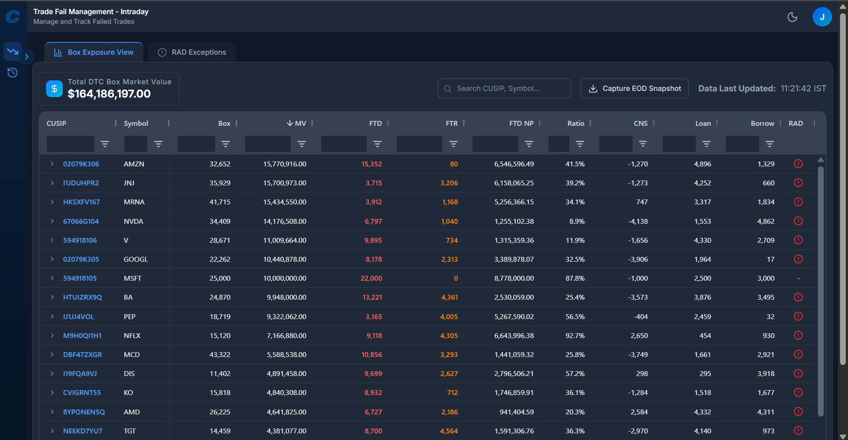

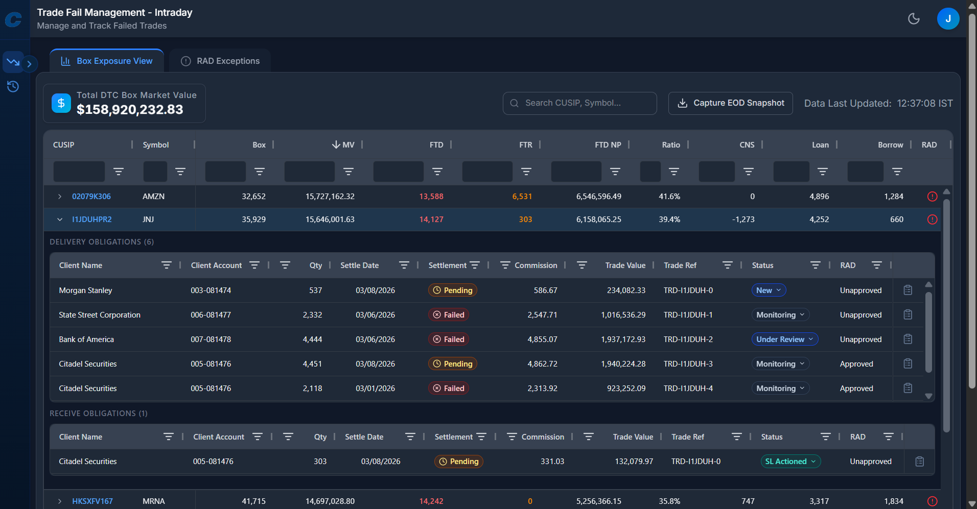

A.2 View 2 – RAD Exceptions View
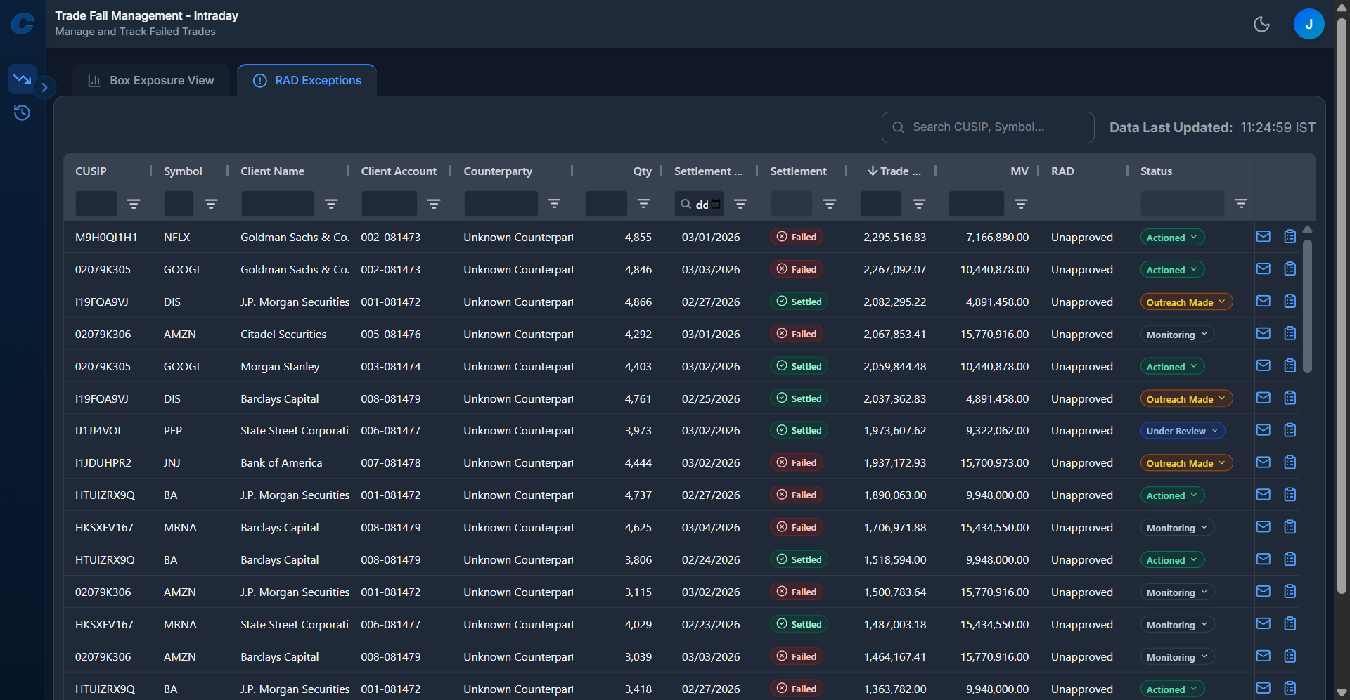

A.2 Notes

